**EXPERIMENT 1: Basic Functions Using Scilab**

**Date:** 08/01/2019

**AIM:** To plot basic functions sine wave, cosine wave, tangent wave and basic signal that are unit impulse, unit step, unit ramp, parabola, square wave, triangular wave and sawtooth wave.

**THEORY:**

In this experiment we are going to plot basic functions and signals in Scilab. Scilab is a free and open source software for numerical computation. It has been developed for system control and signal processing applications.

**Sine Wave –** It is a mathematical curve that describes a smooth periodic oscillation. A sine wave is a continuous wave. It occurs often in pure and applied mathematics, physics, engineering, signal processing and many other fields. It is represented by equation: $y\left(t\right)$ = $A\sin{(2πft+ ∅)}=A\sin{(ωt+ ∅)}$

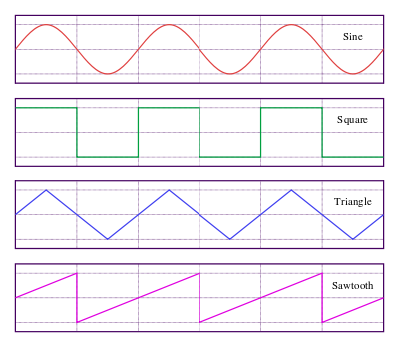

**Cosine Wave –** It is also said to be sinusoidal because $\cos\left(x\right)= \sin{(x+\frac{π}{2})}$. $\cos\left(x\right)$ is a sine wave with phase shift ($∅$) equal to π/2.

**Tangent Wave –**

**Unit Impulse –** It is also known as delta function or Dirac delta function (δ function). It is used to model the density of an idealized point mass or point charge as a function equal to zero everywhere except for zero and whose integral over the entire real line is equal to one. Equation: $δ\left(t\right)=\left\{\begin{aligned}0, &t≠0 \\ 1, &t=0\end{aligned}\right.$

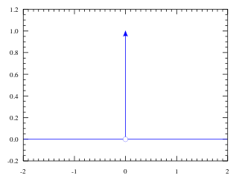

**Unit Step –** It is also known as Heaviside step function (u). It is a discontinuous function whose value is zero for negative argument and one for positive argument. Solution of differential equation represents a signal that switches on at a specified time and stays switched on infinitely. Equation: $u\left(t\right)=\left\{\begin{aligned}0, t<0 \\ 1, &t≥0\end{aligned}\right.$

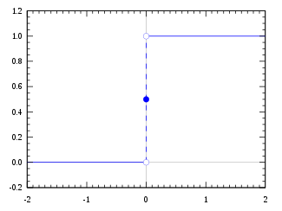

**Unit Ramp –** It is a unary real function, whose graph is shaped like ramp. Unit ramp means the slope of the ramp is unity (1). It has numerous applications in mathematics and engineering. Equation: $R\left(t\right)=\left\{\begin{aligned}0, t<0 \\ t, &t≥0\end{aligned}\right.$

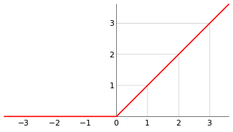

**Unit Ramp –**

**FLOWCHART/ALGORITHM:**

**PROGRAM:**

t = -10:0.1:10; //Time Matrix

*//Sine Wave*

y1 = sin(t); //Sine Function

subplot (4,3,1); //Breaks the graphic window into a 4-by-3 matrix selects 1st plot

xlabel ('Time, t'); //Used to label x-axis

ylabel ('Amplitude, A'); //Used to label y-axis

title ('Sine Wave'); //Gives title to plotted graph

plot (t, y1); //Plots the given function

*//Cosine Wave*

y2 = cos(t); //Cosine Function

subplot (4,3,2); //Breaks the graphic window into a 4-by-3 matrix selects 2nd plot

xlabel ('Time, t'); //Used to label x-axis

ylabel ('Amplitude, A'); //Used to label y-axis

title ('Cos Wave'); //Gives title to plotted graph

plot (t, y2); //Plots the given function

*//Tan Wave*

y3=tan(t);

subplot (4,3,3); //Breaks the graphic window into a 4-by-3 matrix selects 3rd plot

xlabel ('Time, t'); //Used to label x-axis

ylabel ('Amplitude, A'); //Used to label y-axis

title ('Tan Wave'); //Gives title to plotted graph

plot (t, y3); //Plots the given function

*//Unit Impulse*

y4 = zeros (1,201);

for i=1:1: length(t)

if(t(i)==0)

y4(i)=1;

end

end

subplot (4,3,4); //Breaks the graphic window into a 4-by-3 matrix

xlabel ('Time, t'); //Used to label x-axis

ylabel ('Amplitude, A'); //Used to label y-axis

title ('Unit Impulse'); //Gives title to plotted graph

plot (t, y4); //Plots the given function

*//Unit Step*

y5 = zeros (1,201);

for i=1:1: length(t)

if(t(i)>=0)

y5(i)=1;

end

end

subplot (4,3,5); //Breaks the graphic window into a 4-by-3 matrix

xlabel ('Time, t'); //Used to label x-axis

ylabel ('Amplitude, A'); //Used to label y-axis

title ('Unit Step'); //Gives title to plotted graph

plot (t, y5); //Plots the given function

*//Unit Ramp*

y6=zeros (1,201);

for i=1:1: length(t)

if(t(i)>=0)

y6(i)=t(i);

end

end

subplot (4,3,6); //Breaks the graphic window into a 4-by-3 matrix

xlabel ('Time, t'); //Used to label x-axis

ylabel ('Amplitude, A'); //Used to label y-axis

title ('Unit Ramp'); //Gives title to plotted graph

plot (t, y6); //Plots the given function

*//Parabola*

y7=zeros (1,201);

y7=t^2;

subplot (4,3,7); //Breaks the graphic window into a 4-by-3 matrix

xlabel ('Time, t'); //Used to label x-axis

ylabel ('Amplitude, A'); //Used to label y-axis

title ('Parabola); //Gives title to plotted graph

plot (t, y7); //Plots the given function

**RESULT:** We plotted all basic functions in one graphic window using subplot.

**CONCLUSION:**